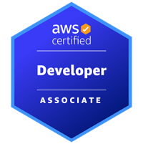
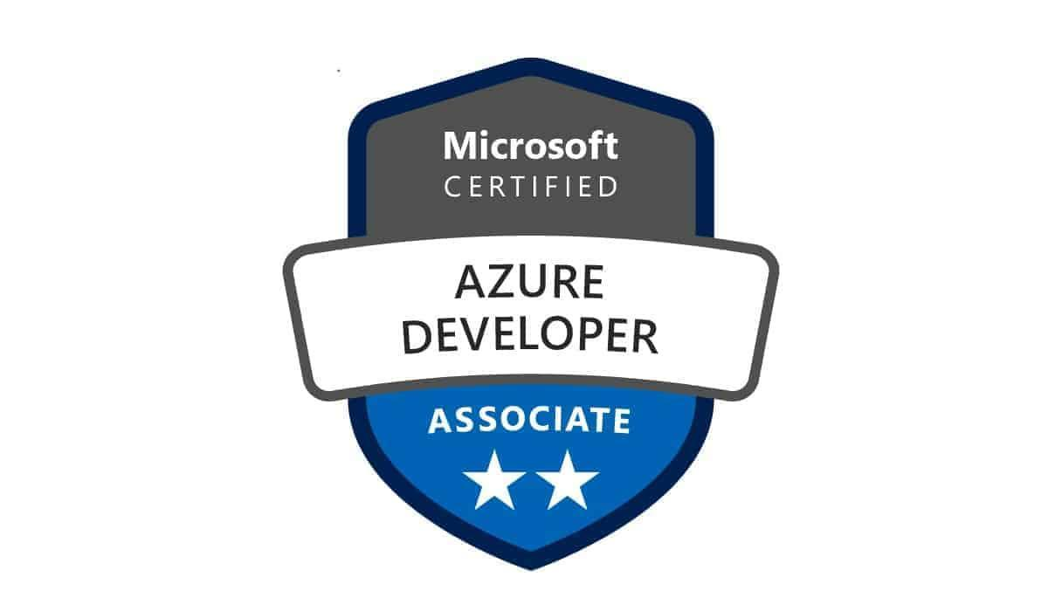
Name:-Rajesh Preetham
Senior Python Developer
Ph No:9082801276
Email:rajeshpreetham17@gmail.com
LinkedIn:https://www.linkedin.com/in/rajesh-preetham/

Professional Summary:

- Senior Python Developer with 10+ years of experience building scalable, cloud-native solutions using Python across AWS, Azure and GCP. Proven expertise in developing robust APIs, automating data workflows, orchestrating cloud services and integrating Python applications into real-time and batch processing systems.
- Proficient in backend and API development using FastAPI, Flask, Django and GraphQL, with secure deployment via AWS API Gateway and Azure API Management.
- Skilled in architecting modular, scalable Python codebases with support for testability, observability and automation in production-grade environments.
- Experienced in writing robust unit, integration and regression tests using Pytest, unittest, moto and tox, following TDD best practices.
- Adept at batch and real-time data processing using PySpark, Spark SQL, Apache Spark, Apache Flink and Apache Beam.
- Hands-on experience with machine learning model deployment using AWS SageMaker, Databricks, Azure Machine Learning, Vertex AI, MLflow and Spark MLlib.
- Proficient in building CI/CD pipelines using GitHub Actions, Jenkins, Azure DevOps, Bitbucket Pipelines, AWS CodePipeline, CircleCI and Argo Workflows.
- Experienced in containerizing Python applications using Docker and deploying them via Kubernetes, AWS ECS, AWS Fargate and Azure Kubernetes Service (AKS).
- Skilled in developing real-time streaming pipelines with Kafka, AWS Kinesis, Azure Event Hubs and message-driven architecture using AWS SQS, SNS and Celery.
- Proficient in data pipeline orchestration using Apache Airflow, Cloud Composer, Prefect, Dagster, Luigi and AWS Step Functions.
- Strong knowledge of structured and semi-structured data handling using pandas, NumPy, Delta Lake, Apache Hudi, Apache Iceberg and Parquet formats.
- Expertise in implementing data validation and testing frameworks with Great Expectations, Amazon Deequ, Soda Core, Pytest and custom validators.
- Proficient in dashboarding and data visualization using Matplotlib, Tableau, Power BI, Looker, Amazon QuickSight, Grafana and Kibana.
- Experienced in writing transformation and automation scripts in Python, PySpark, Bash, Java and using dbt, Databricks Notebooks and Apache NiFi.
- Skilled in managing relational and analytical databases such as Redshift, Oracle DB, MySQL, PostgreSQL, SQL Server, Snowflake, BigQuery and Azure Synapse Analytics.
- Proficient in automating infrastructure provisioning using Terraform, AWS CloudFormation, Azure ARM, Pulumi and Google Deployment Manager.
- Knowledgeable in securing Python applications and environments using IAM, RBAC, OAuth2, AWS Secrets Manager, Azure Key Vault and Google KMS.
- Experienced in monitoring and observability using AWS CloudWatch, Azure Monitor, Datadog, Prometheus, Elasticsearch, OpenTelemetry and Cloud Logging.
- Applied NLP techniques with SpaCy, NLTK and pandas to extract insights from unstructured text data and support intelligent automation.
- Strong documentation and collaboration skills using Confluence, GitHub Wiki, Notion and ReadTheDocs, with a focus on knowledge transfer and maintainability.

Employment History:

Client:Humana,Louisville,KY Duration:-May-2024-Present
Senior Python Developer

Core Project Tasks:
- Designed and deployed scalable batch and streaming pipelines using Python 3.8+, PySpark, and Apache Spark on AWS EMR, reducing data processing latency by 40% for healthcare analytics workloads.
- Led migration from legacy ETL systems to cloud-native AWS architectures, scripting orchestration flows using Boto3, AWS SDKs, and Terraform for zero-downtime cloud adoption.
- Developed backend services and APIs using FastAPI and Flask, exposing real-time clinical metrics and analytics dashboards with auto-generated documentation via OpenAPI/Swagger.
- Built modular Python libraries to interface with AWS S3, Lambda, Kinesis, DynamoDB, improving reusability, maintainability, and deployment consistency across data pipelines.
- Implemented serverless data processing using AWS Lambda and Step Functions, enabling real-time event ingestion, rule-based filtering, and downstream analytics triggers.
- Engineered hybrid transactional/analytical storage layers using SQLAlchemy ORM with PostgreSQL, OracleDB, and DynamoDB, supporting high-frequency medical transaction data.
- Automated ingestion and reporting workflows using Pandas, NumPy, and AWS Glue, significantly reducing manual effort and improving operational observability.
- Built real-time monitoring dashboards using QuickSight and custom Python visualizations, enabling live diagnostics and root cause analysis for patient care and claim processing systems.
- Created anomaly detection frameworks using SciPy, PySpark, and statistical techniques, flagging irregularities in Kinesis-based high-throughput healthcare telemetry pipelines.
- Developed comprehensive test suites with pytest, unittest, and moto, implementing TDD to enforce quality and prevent regressions across evolving microservices.
- Containerized Python microservices with Docker and deployed via AWS Fargate and ECS, improving scalability, startup latency, and environment isolation.
- Built CI/CD pipelines with Jenkins and GitHub Actions, automating linting, testing, and image deployment workflows to reduce release cycles by 25%.
- Refactored monolithic ETL scripts into testable, object-oriented Python modules, improving maintainability and reducing error rates in clinical data workflows.
- Collaborated with data scientists to productionize ML models in SageMaker, using Python APIs, SciPy, and joblib to enable real-time scoring of patient risk and triage models.
- Mentored junior engineers on Python best practices, design patterns, and debugging techniques, while authoring READMEs, onboarding guides, and technical documentation to scale knowledge sharing.

Client:Nomura,Newyork,NY Duration:-Apr-2021-Mar-2024
Senior Python Developer

Core Project Tasks:
- Developed large-scale ETL pipelines using PySpark, Scala, and Google Dataproc, reducing pipeline runtime by 30% and enabling multi-terabyte batch processing for market and trade data.
- Designed real-time streaming workflows using Google Cloud Pub/Sub, Dataflow, and Python, achieving 95% anomaly detection accuracy and high-throughput event processing in capital markets systems.
- Built scalable backend services and APIs using FastAPI and Flask, exposing metadata, analytics, and ML scoring services with OpenAPI-compliant documentation.
- Created reusable Python libraries for ingestion, transformation, and validation logic, improving code modularity, team-wide consistency, and testability across multiple ETL services.
- Wrote extensive unit and integration tests with pytest, unittest, and moto, supporting TDD workflows and pipeline resiliency during rapid feature deployments.
- Tuned complex BigQuery queries and developed Python orchestration scripts for low-latency financial reporting, cutting dashboard query latency by 50%.
- Orchestrated low-latency pipelines using Apache Airflow, Google Dataflow, and BigQuery, automating workflows for risk, pricing, and regulatory reporting.
- Integrated external APIs using requests and Pydantic, applying token-based auth and Google IAM to ensure data access compliance and secure ingestion.
- Automated infrastructure provisioning using Terraform, GCP SDK, and Python CLI tools, enabling repeatable environment setups across dev, staging, and production.
- Deployed ML pipelines with Vertex AI, scikit-learn, and Python, improving fraud and anomaly model accuracy by 18% and enabling scalable model lifecycle tracking.
- Implemented data quality checks using Pandas, NumPy, and Dataflow, achieving 99.9% data accuracy across distributed data feeds and third-party sources.
- Visualized operational metrics and data quality trends using Looker, Matplotlib, and Python reporting scripts for real-time monitoring of pipeline SLAs and job health.
- Containerized services with Docker and deployed to Google Kubernetes Engine (GKE), ensuring high availability and horizontal scaling for low-latency financial APIs.
- Built CI/CD pipelines using Bitbucket, Cloud Build, and Python test hooks for automated builds, test execution, and artifact deployment across environments.
- Mentored junior engineers on production-grade Python, software architecture, and performance tuning, promoting GCP best practices and clean design in data-intensive applications.

Client:PrudentialFinancial,Newark,NJ Duration:-May-2018-Mar-2021
Python Developer

Core Project Tasks:
- Developed scalable RESTful backend services using Python, FastAPI, and Flask, exposing financial data APIs via Azure API Management with token-based authentication.
- Designed relational schemas and indexing strategies in Azure SQL Database and MySQL, integrating with SQLAlchemy ORM to support high-throughput transactional workloads.
- Built real-time dashboards using Azure Power BI, Kibana, and Matplotlib, leveraging Python scripts to visualize system performance and analytics metrics for actuarial teams.
- Architected data warehouse pipelines using Azure Synapse Analytics and Snowflake, orchestrating ELT workflows with Python for large-scale portfolio analytics and risk modeling.
- Engineered event-driven pipelines with Azure Event Hubs, Apache Kafka, and Python to support real-time alerts, trade reconciliations, and fraud signal processing.
- Automated structured and semi-structured data ingestion using Azure Logic Apps, Apache NiFi, and Talend, reducing operational load across reporting systems.
- Designed ETL workflows using Azure Data Factory, PySpark, and Apache Flume, with modular Python logic for data quality, deduplication, and enrichment.
- Built and deployed ML models using Azure ML, Databricks, and Delta Lake, supporting predictive underwriting, customer churn prediction, and lead scoring workflows.
- Integrated SpaCy and NLTK into NLP pipelines for extracting actionable insights from policy documents and customer service logs, enabling smarter automation and classification.
- Provisioned infrastructure using Terraform, ARM templates, and Python SDKs, supporting reproducible cloud setups and reducing manual misconfigurations.
- Containerized Python services using Docker and deployed via Azure Kubernetes Service (AKS), enabling horizontal scaling and resilient service availability.
- Implemented security and RBAC using Azure Active Directory (AAD) and Azure IAM, embedding permission enforcement and identity federation into Python APIs.
- Developed full lifecycle CI/CD workflows with Azure DevOps, GitHub, and custom Python deployment scripts, integrating linting, testing, and artifact packaging.
- Refactored legacy Java and Bash scripts into modular Python code, improving maintainability and reducing operational failure rates in nightly data jobs.
- Authored unit and integration tests using pytest, tox, and unittest, supporting TDD and ensuring test coverage across data services and model pipelines.

Client: Sherwin Williams, Cleveland, OH Duration:-Mar-2016-Apr-2018
Python Developer

Core Project Tasks:
- Developed high-performance Python data processing applications using PySpark on AWS EMR, transforming 5TB+ datasets and reducing processing latency by 40% via efficient schema design, partitioning and caching strategies.
- Designed and managed relational database systems on AWS Redshift and Oracle DB, integrating with SQLAlchemy in Python, optimizing indexing and partitioning to reduce query response time from 5 seconds to 800ms.
- Built and automated robust data pipelines using Python, AWS Glue (Jobs, Crawlers, Triggers), DBT, Apache NiFi and AWS Lambda, improving cross-system data integrity and reducing manual intervention by 60%.
- Created dynamic, real-time analytics dashboards with Amazon QuickSight, Matplotlib and DBT, leveraging custom Python visualizations to drive executive reporting and trend analysis.
- Engineered scalable data warehousing platforms using AWS Redshift and Azure Synapse Analytics, building Python-based orchestration scripts to migrate and optimize 10+ years of historical data.
- Automated complex ETL pipelines for structured and semi-structured data using AWS Glue, Apache NiFi and Azure Data Factory, writing transformation logic in Python, PySpark and Spark SQL to process over 1TB of data daily.
- Implemented infrastructure-as-code workflows using Terraform, AWS CloudFormation and Python-based configuration scripts, reducing cloud environment provisioning time from 3 days to 4 hours.
- Integrated machine learning pipelines using AWS SageMaker, Databricks and Python-based preprocessors, optimizing feature extraction and inference stages with an emphasis on I/O performance.
- Leveraged distributed computing technologies like Apache Spark (PySpark, Spark SQL), Apache Hive and Apache Hadoop (HDFS, YARN) to process billions of records, with performance tuning scripted in Python.
- Developed containerized Python microservices using Docker, AWS ECS and Kubernetes, supporting elastic scale-out and reducing infrastructure cost through efficient container scheduling.
- Built and deployed secure RESTful APIs using Flask, FastAPI, Django and AWS API Gateway, providing robust access to backend analytics and metadata services with JWT-based authentication.
- Designed and maintained real-time monitoring systems using AWS CloudWatch, Datadog, Elasticsearch and Python-based log aggregators, decreasing incident response time from 30 minutes to under 5 minutes.
- Created end-to-end CI/CD pipelines with AWS CodePipeline and CodeCommit, using Python automation scripts for deployment validation, schema migration and version tracking.
- Authored modular data transformation libraries in Python, including unit- and integration-tested modules using pytest, unittest and tox, reducing data validation errors by 35% and enhancing code reusability.
- Automated and scaled background task workflows using Celery, Python and RabbitMQ, increasing reliability and decoupling heavy batch processes from real-time applications.

Client:PittsburghNationalCorporation,Pittsburg,PA Duration:-Dec-2012-Jan-2015
Python Developer

Core Project Tasks:
- Developed scalable big data processing frameworks in Python using Apache Spark (PySpark) and Hadoop, transforming raw datasets into optimized formats to accelerate batch processing and support high-throughput analytics.
- Wrote Python scripts to interface with and optimize Oracle databases, applying indexing, query tuning and schema refactoring to reduce latency and improve throughput under heavy load.
- Built interactive dashboards with Tableau and Power BI, using Python-based ETL scripts to optimize data queries and backend performance, enabling faster rendering and insight delivery.
- Designed and optimized a Snowflake data warehouse, leveraging Python-based orchestration tools to apply performance-driven data modeling, resulting in faster queries and reduced compute cost.
- Engineered real-time data pipelines using Apache Kafka, Spark Structured Streaming and Apache Flink, integrating Python streaming APIs to ensure low-latency data ingestion and high-frequency event processing.
- Automated ETL workflows with dbt and Informatica, integrating Python modules to streamline transformations, eliminate redundancies and reduce pipeline execution time.
- Authored Infrastructure as Code templates using Terraform and AWS CloudFormation, embedding Python-based validation scripts to ensure environment consistency across dev/test/prod stages.
- Managed containerized data applications via Docker and Kubernetes, writing Python scripts for orchestration, health-check monitoring and load management for scalable deployments.
- Improved CI/CD pipelines using Jenkins, embedding Python scripts for automated testing, artifact versioning and deployment rollbacks to accelerate releases with minimal disruption.
- Designed efficient data transformation and cleaning routines in Python, combining Pandas, NumPy and Linux shell scripting to reduce batch times and ensure data quality in large-scale datasets.
- Developed secure, high-performance REST APIs using Flask, supporting low-latency data exchange and reliable service integration across the analytics ecosystem.
- Monitored data pipeline health with Datadog, configuring Python-based custom metrics and alerts to proactively detect performance bottlenecks and maintain high system availability.

Educational Background:

- Bachelors in computer science and engineering.

Training & Certifications:

- AWS Certified Developer Associate.
- Microsoft Certified Azure Developer Associate.

